**DEPLOY A PYTHON APPLICATION ON CONTAINER**

STEP1:Creating a EC2 instance.

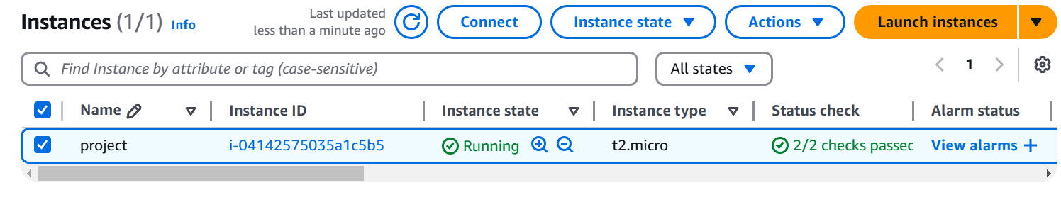

STEP2:Install docker on EC2 instance.

sudo apt update

sudo apt install docker.io

sudo systemctl start docker

sudo docker --version

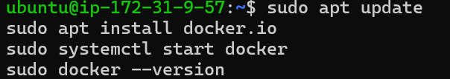

STEP3: Create a mkdir python-app.

In that directory create one dockerfile and

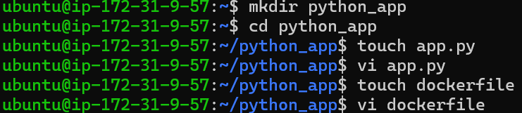

**DockerFile**

# Use the official Python image as a base

FROM python:3.9

# Set the working directory in the container

WORKDIR /app

# Copy application code and requirements file into the container

COPY app.py .

COPY requirements.txt .

# Install any needed packages specified in requirements.txt

RUN pip install --no-cache-dir -r requirements.txt

# Command to run the application

CMD ["python", "app.py"]

**app.py**

# app.py

from flask import Flask

app = Flask(__name__)

@app.route('/')

def hello_world():

return 'Hello, World!'

if __name__ == '__main__':

STEP4:Install python



STEP5:Build the image

docker build -t my-python-app .

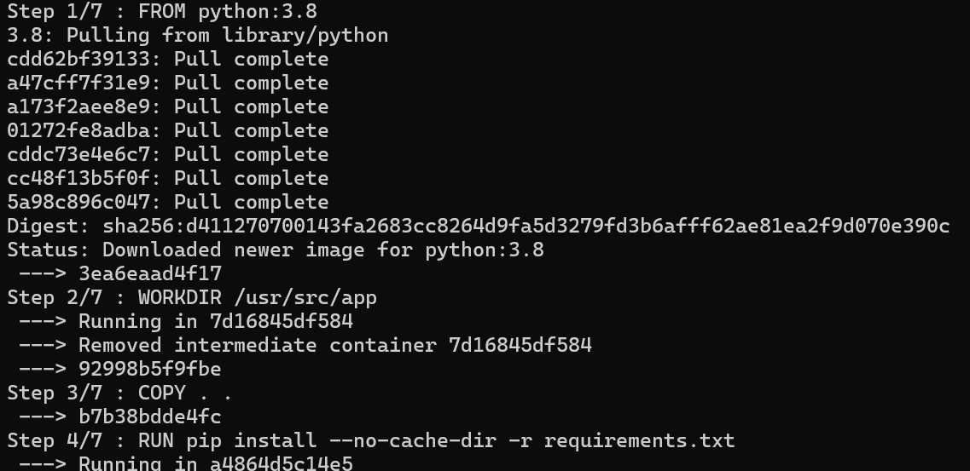

STEP6:Check the image

STEP7:Build The Container

